PIN (Part 2)

Set- up:
There are minimum 3 pieces staying on the same line (files, ranks or diagonals) with the last 2 belongs to one side: they are the pinned piece and the King. The set-up is as follow:


Pinning piece Pinned piece King
(Queen, Rook, Bishop)

Action:
- Attack the pinned piece by a lesser piece (usually pawns) to win it or the target (see game 4).
- Capture the piece or pawn which is defended by the pinned piece because the pinned piece can only move on the pinning line or cannot move at all. (see games 1,2, 3).

Goal:
To win material advantage or checkmate.

Examples:
In the following games we shall examine how to execute the pin in practice.
Game 1:

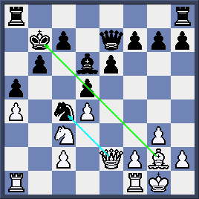
Black King at b7 stays on the same diagonal with White Bishop at g2 so Black pawn d5 is pinned. Thus, White wins the Knight by 1.Qxc4 (diagram 1a).

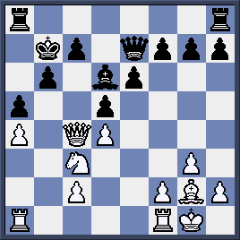
Pawn at d5 is covering the King so it is unable to recapture White Queen (diagram 1b).

Game 2:

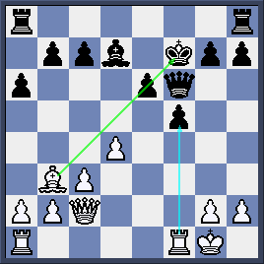
By 1.Rxf5 White bags the Queen thanks to double pins (diagram 2a).

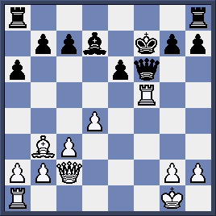
Pawn at e6 is pinned on a2-g8 diagonal so it cannot take the White Rook (diagram 2b).

Game 3:
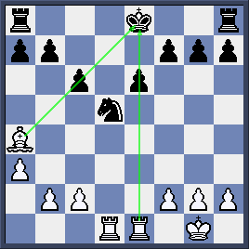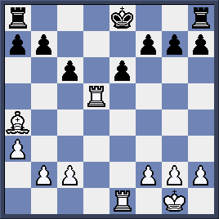
Black Knight at d5 seems alright at first but both his pawn defenders are pinned on a4-e8 diagonal and e-file respectively (diagram 3a). White makes full use of that fact by taking the Knight for free 1. Rxd5! (diagram 3b)
Game 4:
White wins Black Knight by the following moves (diagram 4a).
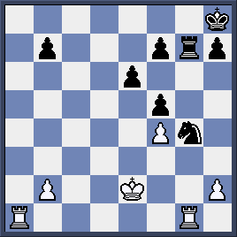
1. Ra8+ Rg8 2. Rxg8+ Kxg8 (diagram 4b)

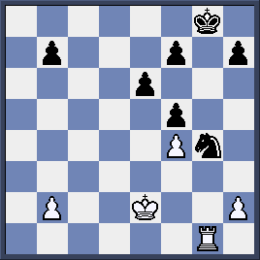
3.h3! and Black loses the Knight due to the pin.

Quizzes:
Whites moves and wins material in the following 4 games.
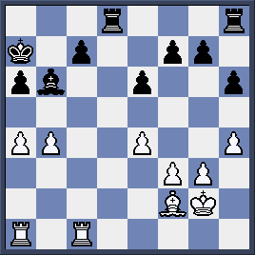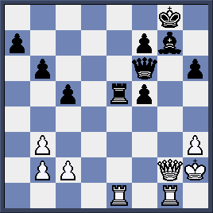
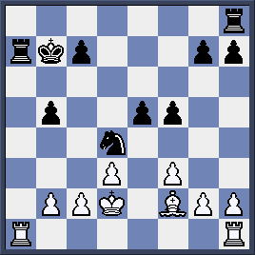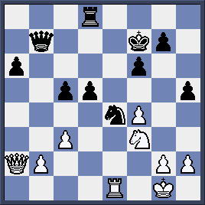
White moves and checkmates in 2 moves in the following 2 games
